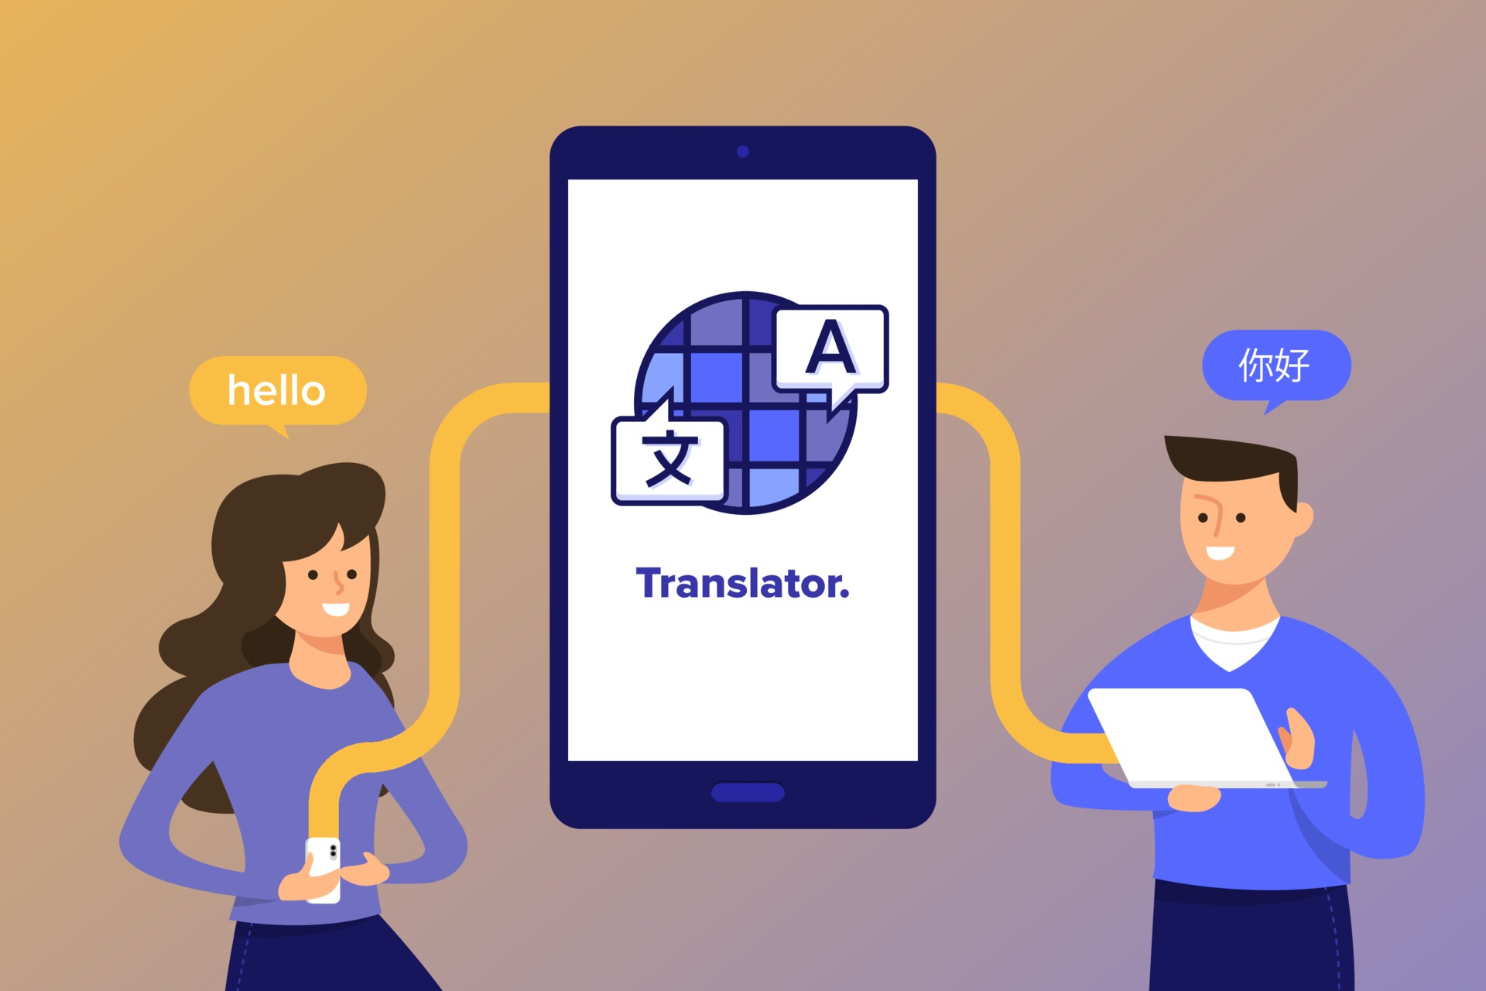

Language Translator Apps use Machine Learning by applying different Natural Language Processing (NLP) techniques and algorithms to convert or translate one language to another. The Machine Learning model is trained on vast amounts of data to understand the context, recognize patterns and generate accurate translations. 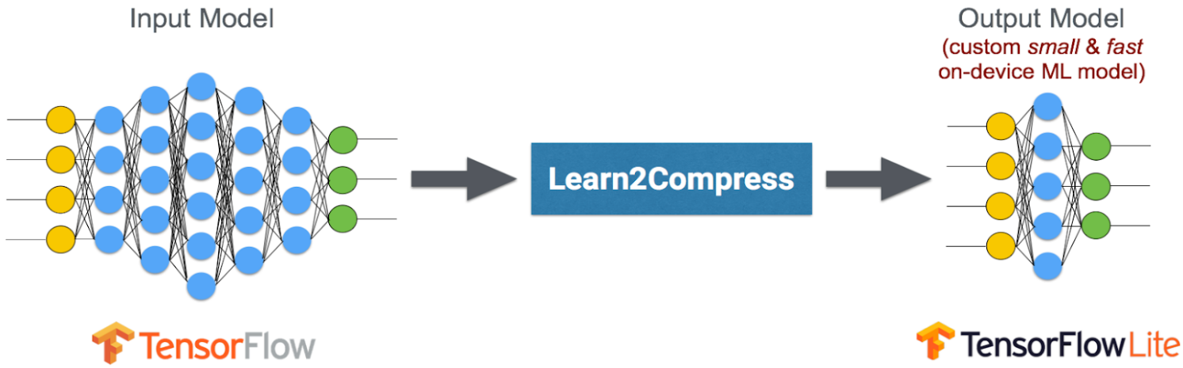

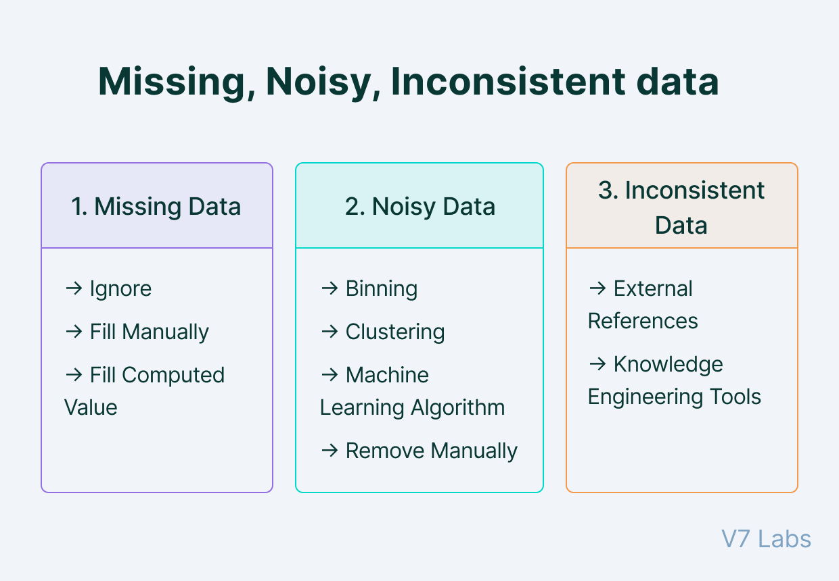

Preprocessing of the text usually starts with cleaning, normalization, and stemming of the text. By cleaning, any noise or irrelevant content such as special characters or punctuation is removed to enhance the translation quality. Normalization is done to convert numbers to their text form, remove stop words, and transform text to the lower case. Stemming involves reducing the word to its root form so that variations of the same word do not affect the translation accuracy.

To maintain the structure and meaning of the sentence, Language Translation Apps use different techniques such as neural machine translation, statistical machine translation, and rule-based machine translation. Task_4 is based on this.

In neural machine translation, a neural network is used to generate translations and understand the semantics of the text. The neural network learns from vast amounts of training data, and over time, it generates increasingly accurate translations. The neural network takes into account the context of the sentence and tries to translate the whole sentence as a single unit, rather than translating each word separately.

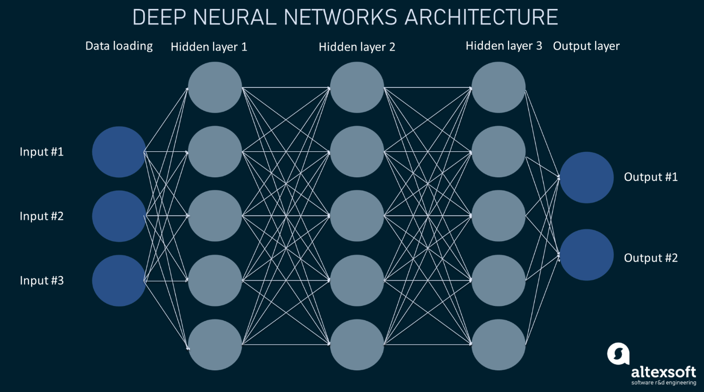

Statistical Machine Translation (SMT) works based on statistics and tries to find the most probable translation based on the past translations. SMT employs various mechanisms to capture the nuances of the language, such as phrase-based, word-based, and model-based translation.

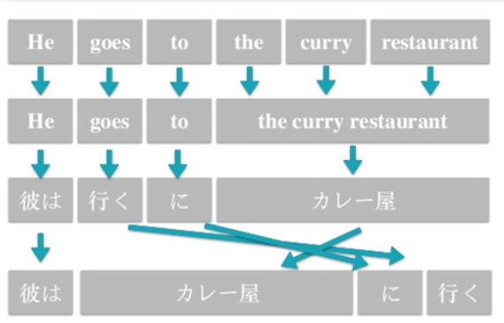

Rule-based Machine Translation (RBMT) involves a set of rules which are programmed to translate the text from one language to another. The rules usually consider the grammar rules, syntax, and vocabulary of both languages. Rule-based machine translation is useful for translating structured texts like legal documents or technical manuals.

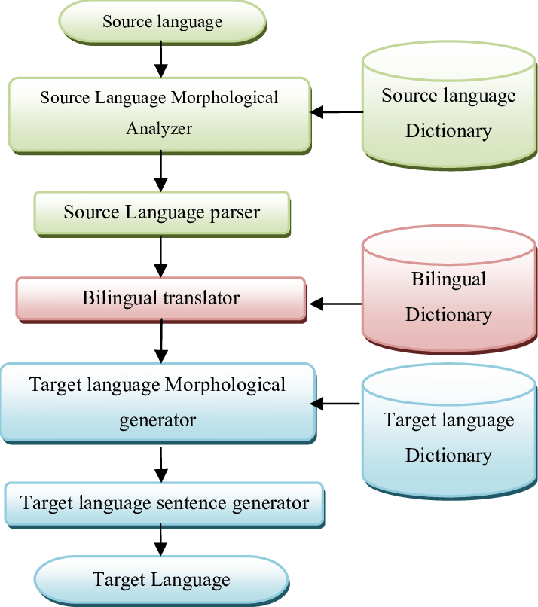

In conclusion, Language Translators Apps use Machine Learning to understand the context, recognize patterns, and generate accurate translations. It involves cleaning, normalization, and stemming of text, followed by translation techniques like neural machine translation, statistical machine translation, and rule-based machine translation. These techniques help maintain the structure and meaning of the sentence while translating it.